11/28/2022

Group Members:: Ives, Aguilar, Pedersen, Crandall, Gayle

Useful Links:

Discord: <https://discord.gg/XVktNuVw>

**Milestone #1:**

**Case Study: Bacchus Winery**

**Business Rules:**

* **Inventory is tracked by item_no and relates to the items table**
* **Distributors can have many items associated with their ID**
* **Inventory orders (inbound_orders) are tracked by comparing expected_delivery_date with actual_delivery_date**
* **Contact table houses employee, distributors, and suppliers contact information by distinct contact_id’s**
* **One employee is associated with one payroll**
* **One department has many employees and managers**
* **One employee is associated with many work_hours entries**
* **Outbound orders are associated with distributors they are sent to with the distribution table**

**ERD:**

[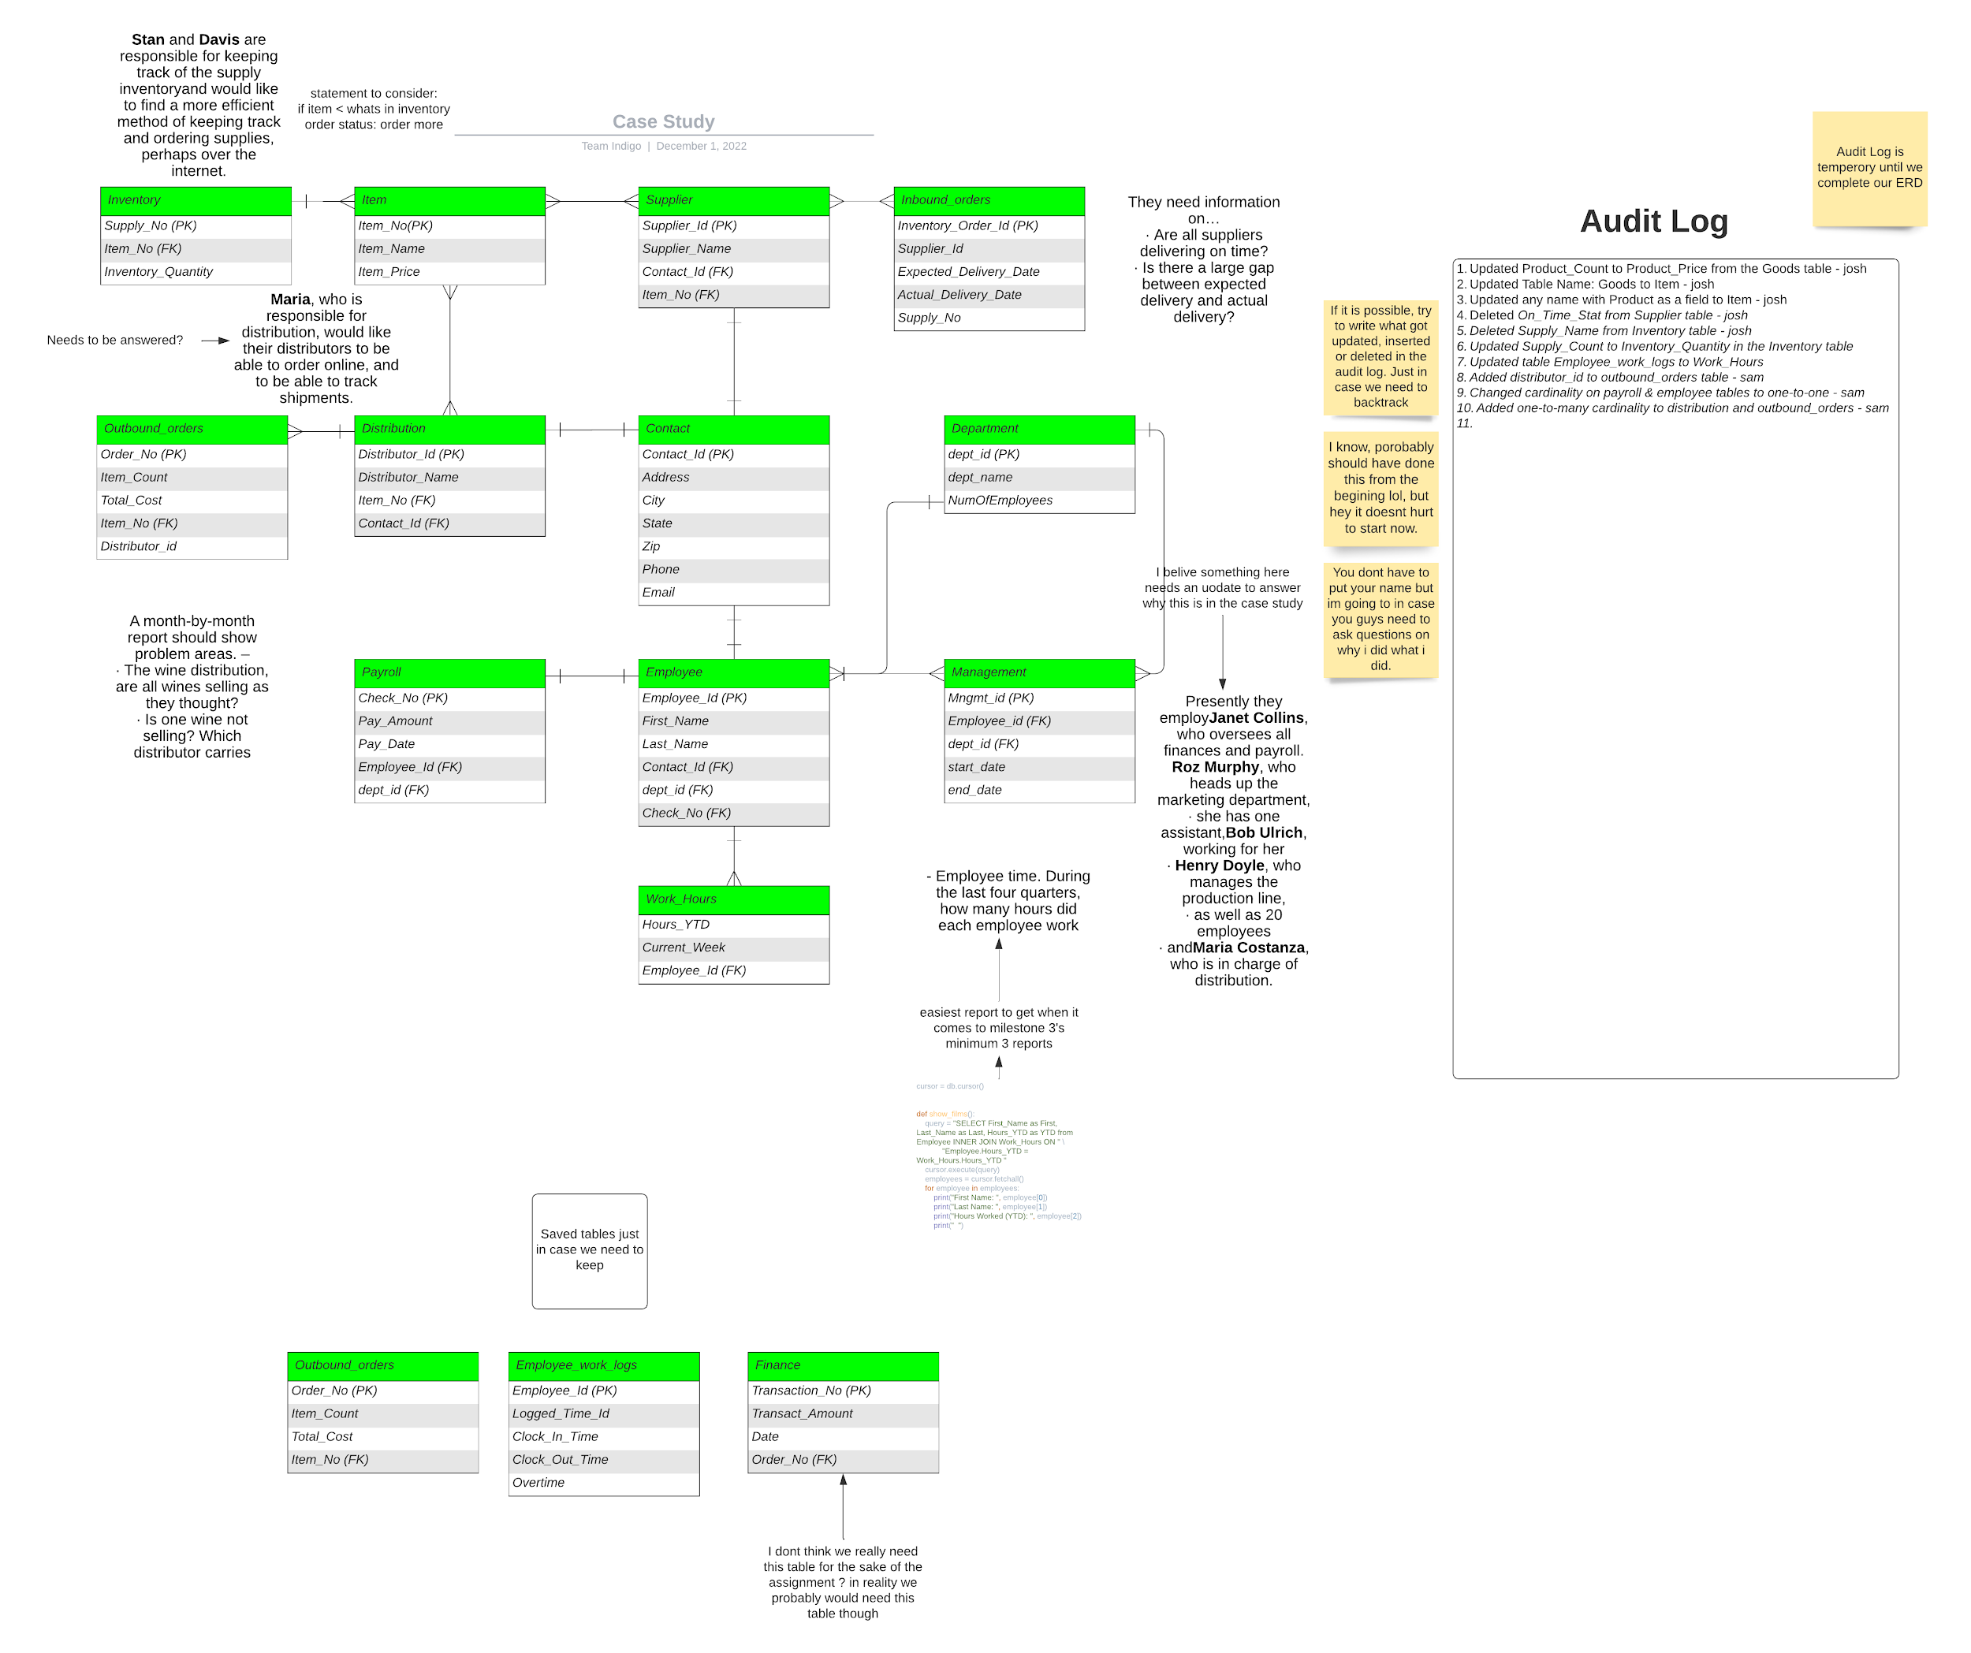](https://lucid.app/lucidchart/ea6047ce-7a2b-4ffb-9b26-b5a914458b5a/edit?page=0&v=5509&s=544)

**Milestone #2:**